Biodegradation of pesticides
A pesticide is any substance or mixture of substances intended for preventing, destroying, repelling, or mitigating any pest (insects, mites, nematodes, weeds, rats, etc.), including insecticide, herbicide, fungicide, and various other substances used to control pests .
General characteristics of pesticides
Pesticides | Characteristics | Examples
Organochlorines | Soluble in lipids, they accumulate in fatty tissue of animals, are transferred through the food chain; toxic to a variety of animals, long-term persistent. | DDT, aldrin, lindane, chlordane, mirex.
Organophosphates | Soluble in organic solvents but also in water. They infiltrate reaching groundwater, less persistent than chlorinated hydrocarbons; some affect the central nervous system. They are absorbed by plants, transferred to leaves and stems, which are the supply of leaf-eating insects or feed on wise. | Malathion, methyl parathion, diazinon
Carbamates | Carbamate acid derivatives; kill a limited spectrum of insects, but are highly toxic to vertebrates. Relatively low persistence | Sevin, carbaryl
Pyrethroids | Affect the nervous system; are less persistent than other pesticides; are the safest in terms of their use, some are used as household insecticides. | Pyrethrins
Biological | Only the Bacillus thuringiensis (Bt) and its subspecies are used with some frequency; are applied against forest pests and crops, particularly against butterflies. Also affect other caterpillars. | Dispel, foray, thuricide
In natural environments, pesticides or their degradation products transformed or degraded by microorganisms or eventually leading to complete degradation by the microbial consortium.
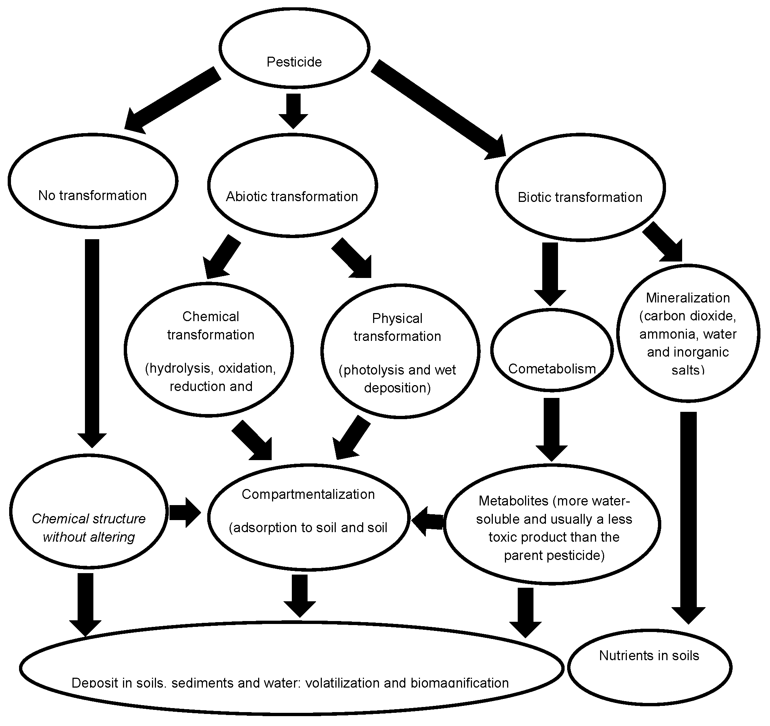
Figure: Fate of pesticides in the environment.

The fate of pesticides in the environment is related to the soil sorption processes that control not only their transfer but also their bioavailability.

Microorganisms involved in the biodegradation of pesticides

Different biological systems, as microorganisms, used to biotransform pesticides. Furthermore, the isolated microorganisms capable of degrading pesticides used for bioremediation of other chemical compounds.

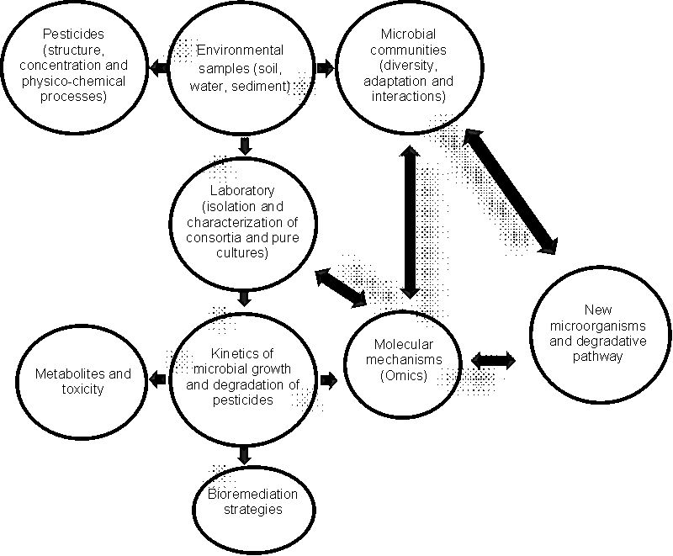

Figure : Representation of the relationships between pesticides, microbial communities, and the discovery of new biodegradation processes, Omics = high throughput-based characterization of biomolecules characteristic of bioprocesses; DNA, genomics; mRNA, transcriptomics; protein, proteomics; metabolites, metabolomics.

Pseudomonas, is the most efficient bacterial genus for the degradation of toxic compounds.The species Botrytis cinerea could eliminate the linuron and metroburon herbicides. Trichoderma viridae has ability in the endosulfan and methyl parathion pesticides degradation. bacterium Rhodococcus sp. degrade triazines to nitrate. After microbial action this compound was transformed into nitrite (30%), nitrous oxide (3.2%), ammonia (10%) and formaldehyde (27%). Some bacteria isolated from the soil are capable of degrading pesticides as ethyl-parathion and methyl-parathion.
Mechanism of Biodegradation
Biodegradation involves transferring the substrates and products within a well-coordinated microbial community, a process referred to as metabolic cooperation. Microorganisms have the ability to interact, both chemically and physically, with substances leading to structural changes or complete degradation of the target molecule. Among the microbial communities, bacteria, fungi, and actinomycetes are the main transformers and pesticide degraders . White rot fungi is a promising bioremediation agents. This ability arises from the production of extracellular enzymes that act on a broad array of organic compounds. Some of these extracellular enzymes are involved in lignin degradation, such as lignin peroxidase, manganese peroxidase, laccase and oxidases.
Enzymes are central mode of action of many pesticides: some pesticides are activated in situ by enzymatic action, and many pesticides function by targeting particular enzymes with essential physiological roles. Enzymes are also involved in the degradation of pesticide compounds, both in the target organism, through intrinsic detoxification mechanisms and evolved metabolic resistance, and in the wider environment, via biodegradation by soil and water microorganisms. For pesticides degradation, three enzyme systems involved: hydrolases, esterases (also hydrolases), the mixed function oxidases (MFO), these systems in the first metabolism stage, and the glutathione S-transferases (GST) system, in the second phase .
The process of biodegradation depends on the metabolic potential of microorganisms to detoxify or transform the pollutant molecule, which is dependent on both accessibility and bioavailability .
Metabolism of pesticides involve a three-phase process. In Phase I metabolism, the initial properties of a parent compound are transformed through oxidation, reduction, or hydrolysis to a more water-soluble and usually a less toxic product than the parent. The second phase involves conjugation of a pesticide or pesticide metabolite to a sugar or amino acid, which increases the water solubility and reduces toxicity compared with the parent pesticide. The third phase involves conversion of Phase II metabolites into secondary conjugates, which are also non-toxic. In these processes fungi and bacteria are involved producing intracellular or extra cellular enzymes including hydrolytic enzymes, peroxidases, oxygenases, etc .
Enzyme | Organism | Pesticide
Oxidoreductases (Gox) | Pseudomonas sp. LBr  Agrobacterium strain T10 | Glyphosate
Cyp76B1 | Helianthus tuberosus | Linuron, Chlortoluron and Isoproturon
P450 | Pseudomonas putida | Hexachlorobenzene and Pentachlorobenzene
Dioxygenases (TOD) | Pseudomonas putida | Herbicides Trifluralin
TfdA | Ralstonia eutropha | 2,4 - dichlorophenoxyacetic acid and pyridyl-oxyacetic
DMO | Pseudomonas maltophilia | Dicamba
Figure: Relevant enzymes in the bioremediation of pesticides

